The SSI Framework

Socioscientific Issues (SSI) provide a strong framework for engaging students and teachers in meaningful and relevant scientific discourse in the development of functional scientific literacy. The framework, “focuses specifically on empowering students to consider how science-based issues and the decisions made concerning them reflect, in part, the moral principles and qualities of virtue that encompass their own lives, as well as the physical and social world around them” (Zeidler, Sadler, Simmons, and Howes 2005, p. 360). However, SSI is not typically integrated in teaching STEM subjects even when teachers apply the disciplinary core ideas (e.g. physical and life sciences), the science and engineering practices (e.g. developing and using models), and the crosscutting concepts (e.g. cause and effect) based on the Next Generation Science Standards (NGSS Lead States 2013).

Zeidler et al. (2005) refer to cultural issues as the cultural-embeddedness of science. Addressing cultural issues in the science classroom includes addressing scientific concepts as they are situated within the students’ cultural perspective. This type of culturally responsive teaching was defined by Gay (2002) as “using the cultural characteristics, experiences, and perspectives of ethnically diverse students as conduits for teaching them more effectively. It is based on the assumption that when academic knowledge and skills are situated within the lived experiences and frames of reference of students, they are more personally meaningful, have higher interest appeal, and are learned more easily and thoroughly” (p. 106).

SSI education explores the impact of student engagement in culturally relevant, scientific issues on their development of scientific literacy and understanding, as well as morality and ethics. The development of this cognitive and ethical scientific literacy is broken into four component parts, nature of science issues, case-based issues, classroom discourse issues, and cultural issues. Students’ understanding and application of the nature of science influences how they make evidence based decisions to address preconceived notions regarding SSIs.

References

Gay, G. (2002). Preparing for culturally responsive teaching. Journal of Teacher Education, 53(2), 106-116.
Macalalag, A., Johnson, J., & *Lai, M. (Under Review). Teachers’ notions of cultural practices associated with reducing carbon dioxide and their intentions to teach socio-scientific issues. Cultural Studies in Science Education.
Macalalag, A., Johnson, J., & *Lai, M. (2017). STEM Education Course: Enhancing K-12 Teachers’ Cultural Awareness Through Reflections of Socioscientific Issues. Pennsylvania Teacher Educator, Volume 16, Pages 76 – 92, Fall 2017.
https://scholarworks.arcadia.edu/school_edu_faculty_work/4/
Zeidler, D. L., Sadler, T. D., Simmons, M. L., & Howes, E. V. (2005). Beyond STS: A research‐based framework for socioscientific issues education. Science Education, 89(3), 357-377.

Features of an SSI Curriculum

Taken from Zeidler, D.L. & Kahn, S. (2014, page 4). It’s Debatable! Using Socioscientific Issues to Develop Scientific Literacy K-12. Arlington, VA: NSTA Press.

Socioscientific Issues (SSI) Curriculum is | Socioscientific Issues (SSI) Curriculum is not
A research-based, interdisciplinary approach that enlists higher order problem-solving, argumentation, and research skills to analyze challenging, contextualized scientific concepts and issues. | A “cookbook” approach to scientific exploration that emphasizes “one right method” and predictable outcomes.
A method that uses real-world scenarios and real data in order to prepare students for their future roles as societal decision makers. | Simplistic use of hypothetical scenarios that are irrelevant to students’ lives.
A conduit for scientific argumentation and discourse skills that mimic the manner in which real scientists research, discuss, debate, and deliberate scientific issues. | Emphasis on esoteric debates that allow students to contribute opinions rather than evidence.
A relevant and meaningful context for probing students’ moral/ethical beliefs on controversial issues while guiding them to become tolerant and open to conflicting opinions and perspectives. | Reliance on “safe” subjects that avoid emotional connections and moral/ethical dilemmas.
A logical approach for modeling nature of science including the tentativeness of scientific conclusions, the importance of rational argument and skepticism, the role of creativity, and the distinction between science and pseudoscience. | A traditional approach to scientific methodology, which fails to recognize the varying social, contextual, and personal influences that contribute to scientific progress.

The SSI Learning Cycle

Sadler, T. D., Friedrichsen, P., & Zangori, L. (in revised) A Framework for teaching for socio-scientific issue and model based learning (SIMBL). Submission for special issue Science-Technology-Society-Environment Education: dialogues and paths for the interdisciplinarity and transdisciplinarity, Journal Educação e Fronteiras" /Education and Borders.

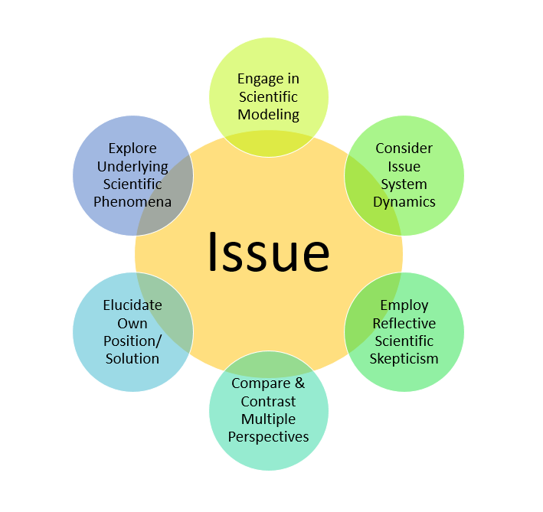

Identify the issue | Identify the socioscientific issue by reviewing “newspapers, books, Internet sources, professional science education-related journals and television/movies for current issues related to your subject matter and course objectives. There are local and global controversies related to almost any science topic. As you explore topics, consider students’ interests and selected topics with relevance to their lives and the [school’s] curriculum” (Zeidler & Kahn, 2014, page 31).
Explore and explain the underlying scientific phenomena | Think of opportunities for students to explore and explain the scientific phenomenon associated with the focal issue. This anchor phenomenon must be relevant to students’ everyday experiences, observable, complex, have associated data, text and images, and part of the school’s curriculum (Sadler, Friedrichsen, & Zangori, in revise).
Engage in scientific modeling | Allow students to engage in scientific modeling and reasoning through development, use, evaluation, and revision of scientific models. Models are used to convey and explain information as well as to predict future events. Example classroom models include: conceptual (e.g. drawings and sketches), mathematical (e.g. graphs and equations), physical (e.g. stream table), and computer-oriented model (e.g. online simulation). (Macalalag, 2012)
Consider issue system dynamics | Ask students to consider a system associated with their SSI. The system may include interactions of humans with nature as well as social elements such as political, economic, ethical, and religious considerations.
Employ reflective scientific skepticism | Teach students to consider the following questions while reviewing their data and sources of information:  - Who is the author or organization disseminating the information?  - What is the purpose of the publication?  - What expertise and/or relevant experiences does the author have?  - What biases could affect the presentation of the information?  (Sadler, Friedrichsen, & Zangori, in revise).
Compare and contrast multiple perspectives | Ask students to obtain and evaluate information from a range of stakeholders such as environmental activists, politicians, political groups, researchers, scientists, religious organizations, and media.
Elucidate own position/solution | Engage students to defend and explain their position and/or propose a solution to the SSI. Ask students to use their data to explain their position and/or solution, explain the strengths and weaknesses of their claims, and identify their personal biases and possible limitations.

Example SSI Topics

Taken from Zeidler, D.L. & Kahn, S. (2014, page 32). It’s Debatable! Using Socioscientific Issues to Develop Scientific Literacy K-12. Arlington, VA: NSTA Press.

Genetically Modified Foods | Cell Phones and Health | Sunscreen: Help or Harm?
Milk: Animal vs. Soy? | Medical Marijuana | Fast Food Limits
Animal Dissection in the Classroom | Alternative vs. Fossil Fuels | Paper or Plastic Bags?
Is Coffee Good for you? | Bicycle Helmet Laws | Stem Cell Therapy
Sex-Change Surgery | Fur Ban | Mandatory Fat Camps
Offshore Oil Drilling | Animal Research | Steroids in Sports
Alcohol Consumption | Hunting for Population Control | Beach Enrichment
Farm-Raised vs Wild-Caught | Plastics and the Environment | Tap vs. Bottled Water
“Designer” Babies | Space Settlements | Global Warming
Deforestation | Vaccinations | Fluoride in Water
Reproductive Issues | Long-Line Fishing | Herbal Remedies
Antibiotics | Locating Landfills | Satellite Tracking and Privacy
Cochlear Implants | Smoking Bans | Fracking
Euthanasia | Exotic Animals as Pets | Land Use
Cloning | CFL vs. Incandescent Bulbs | Texting and Distraction

SSI Lesson Plan

Grade/ Grade Band: | Topic: | Lesson # _____ in a series of _____ lessons
Brief Lesson Description:

Description and Explanation of SSI:

Specific Learning Outcomes:

Narrative / Background Information
Prior Student Knowledge:
Science and Engineering Practices | Disciplinary Core Ideas: | Crosscutting Concepts:
Possible Preconceptions/Misconceptions:
Standards: Education for Sustainability and PA Core
LESSON PLAN
ENGAGE: Establish relevancy - help learner determine need of learning new concepts
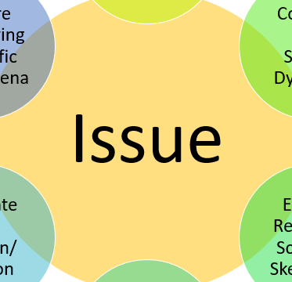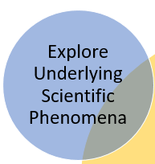
EXPLORE: Present the content - help learner understand concepts, process/procedures, facts or principles
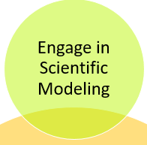

EXPLAIN: Improve understanding - help learner express new learning and provide guidance

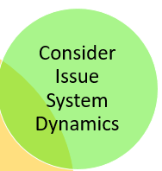
ELABORATE: Construct new learning - help learner apply prior learning and acquire new

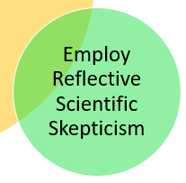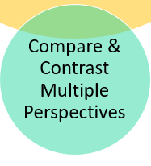

EVALUATE: Assess learning - help learner measure learning against its corresponding goals
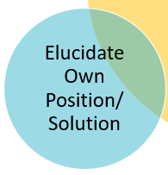
Elaborate Further / Reflect: Enrichment:

